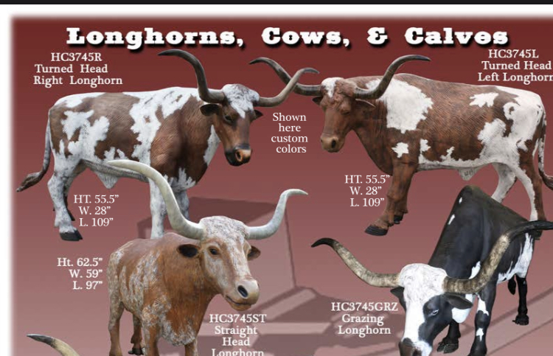
HISTORY OF THE TURKEY TRACK TRAIL AND THE LONGHORN STATUE PROJECT
Before we became a flyover state, we were a crossroads, and before that, we were a dirt track thruway trail. When we sat down as the ag committee, we, like so many others, asked, "How can we help this town boom again? How can we invite locals to stay and passersby to stop?"
As we look to the future of Cushing, we couldn't help but take a look back. Through our history scroll of oil booms and city water parks, we were reminded of our deep agriculture and cattle roots. Did you know where our town sits today used to be a round-up ground for cattle driven north from Texas as far back as 1866? Did you know in the 1880s, just outside of town, thirty men operated a 253,648-acre ranch with 150 saddle horses and 20,000 head of cattle?
Before Cushing was Cushing, the Turkey Track Ranch and our area was known by Indians, cattlemen, and others. The Saginaw Cattle Company of Michigan leased the land from the Sac & Fox Nation in Indian Territory. The ranch was a famed trading post and oasis on one of the oldest runs through Tulsa, Creek, and Payne counties. Initially created by Indian buffalo hunters and once named Red Fork Trail after the river it parallels, it was later and most notably known as the Turkey Track Trail after the ranch. The history includes tales of being a hide-out of the Daltons, and some cowboys of the ranch later became bandits and joined the Doolin gang when the ranch closed.
So if you've ever watched an old western, read in a history book, or heard people talking of the wild wild west and thought it was far west of here, think again. This area was wild even before land runs and oil fields. Oh, if this ground could talk. Can you imagine the stories it would tell that the history books never had a chance at capturing?
Drive down the road and around the country mile today, and you'll still see them out there. Cattle can be seen grazing, roaming, and producing. They are rooted in our history, and agriculture is a mainstay of our community. Naturally, our top priority is nurturing our community in agriculture. From spotlighting local farms and ranches to bringing local food and rural experiences to our community for all to enjoy, it's all on our list, and we are excited to share our first project with you.
We have taken note of other towns in Oklahoma and see it fitting for us to join in and share the fun of having painted statues around town for all to enjoy. These longhorn cattle are a nod to our past, enjoyment for today, and hope for the future. The cattle show togetherness by showing a common thread throughout town, uniquely feature local businesses, and provide a great photo opportunity for locals and passersby alike. They are a reminder to all that our history is deeply rooted and wildly diverse. We expect conversations about new ones, freshly painted ones, and prominent locations of these cattle. Of course, we also expect these to become landmarks used for directions. "Turn right when you see the orange longhorn."
Can you picture it? Buzz will be in the air and visible to all that Cushing means business, and we are more passionate than ever to come together and build our town's future. Will you join us? We have an incredible ground floor opportunity that puts your business front and center on what's coming next in our town.
If your business would like to be a part of this project, please fill out the sponsorship form below. Longhorn statues are $1,500 Each and only (7) are available during this first year. This group of sales will deliver to Cushing around May 2022. Longhorn Statue Sales will open back up every year around October and will close every year around the end of November, to ensure enough time to order the Longhorn statues and get them delivered to you. The sales of the Longhorn Statues will only happen for a couple of years; so there is only a LIMITED AMOUNT that will be offered. NOW is the time to get yours!
All Longhorn statues will come to you raw. We will help you anchor the statue on your business land, whereever you would like it; you will also have the option to paint them however you like. You can put your business logo on it; make it colorful; make it something that represents your business. It's yours!
Once there are enough Longhorns purchased to develop a tour map, we will have all Longhorns mapped out with your business address to help the public find your Longhorn statue. Many people LOVE to visit communities that have statues such as these, so we are really looking forward to the tourism they will bring in, and the new customers they will bring to your business.
Questions? Give us a call at the Cushing Chamber office at 918-225-2400

SPONSORSHIP FORM
STATUES ARE $1,500 EACH AND DELIVERY TO CUSHING WILL BE MAY 2022
DEADLINE: MARCH 31, 2022

Name of Company_______________________________________________________________________

Billing Address_________________________________________________________________________

_______________________________________________________________________________________

Contact Person__________________________________________________________________________

Phone__________________________________________________________________________________

Fax_____________________________ Email_________________________________________________
Any additional emails needing to receive info:__________________________________________________
____________________________________________________________________________________
# Of Statues: ____________________________________________________________________________
**All Credit card payments will have a 4% credit card processing fee added to total invoice. All invoices are due upon receipt. Make checks payable to: Cushing Chamber of Commerce, billing address is 1301 E. Main Street Cushing, OK 74023.

